Alissa Skog

PS239T: Final Project

Results

**Recidivism Analysis**

Of the 5,914 sample **45.9 percent recidivated**. A quick comparison between the initial crime and subsequent crime is included in the table below. Interestingly, we see Battery as a high original crime at 23.6%, but not a common crime when we look at the recidivism data. Also, as expected, it looks like a lot of individuals have their recidivating event as a suspended license. This would be an interesting piece to look into if further data was available.

|  |
| --- |
|  |
| Original Crime | Assault | Batt. | Burglary | Child Assault | Drug | DUI | Other | Robb. / Theft | Sex | Susp. |  |
| Assault | 0.10% | 0.50% | 0.00% | 0.10% | 0.50% | 0.40% | 1.00% | 0.20% | 0.00% | 0.10% | **2.90%** |
| Battery | 0.20% | 4.00% | 0.30% | 0.30% | 3.60% | 2.70% | 7.10% | 2.50% | 0.20% | 2.70% | **23.60%** |
| Burglary | 0.00% | 0.30% | 0.20% | 0.00% | 1.00% | 0.20% | 1.80% | 1.10% | 0.00% | 0.60% | **5.20%** |
| Child Assault | 0.00% | 0.20% | 0.00% | 0.00% | 0.20% | 0.20% | 0.70% | 0.20% | 0.00% | 0.40% | **1.90%** |
| Drug | 0.10% | 1.30% | 0.20% | 0.20% | 8.70% | 220% | 6.60% | 2.50% | 0.40% | 3.00% | **25.20%** |
| DUI | 0.00% | 0.60% | 0.10% | 0.10% | 1.00% | 2.50% | 2.40% | 0.70% | 0.00% | 2.10% | **9.50%** |
| Other | 0.00% | 1.20% | 0.30% | 0.20% | 3.20% | 1.40% | 5.50% | 1.50% | 0.00% | 1.90% | **15.20%** |
| Robb./Theft | 0.10% | 0.40% | 0.20% | 0.10% | 2.20% | 0.90% | 3.90% | 4.50% | 0.00% | 1.10% | **13.40%** |
| Sex | 0.00% | 0.00% | 0.00% | 0.00% | 0.20% | 0.00% | 0.00% | 0.10% | 0.10% | 0.00% | **0.40%** |
| Susp. | 0.00% | 0.10% | 0.00% | 0.10% | 0.30% | 0.70% | 0.50% | 0.20% | 0.00% | 0.90% | **2.80%** |
|  | **0.50%** | **8.60%** | **1.30%** | **1.10%** | **20.90%** | **11.10%** | **29.50%** | **13.50%** | **0.70%** | **12.80%** |  |

**Recidivism by Crime Type**



This graph shows us that proportionally, individuals convicted of sex offense are more likely to recidivate in the first three months after release.

**Subsequent Recidivism Types: Sex Assault and Child Abuse**

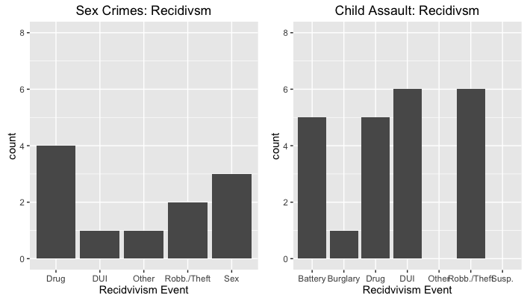

**Recidivism Crimes: Word Cloud**

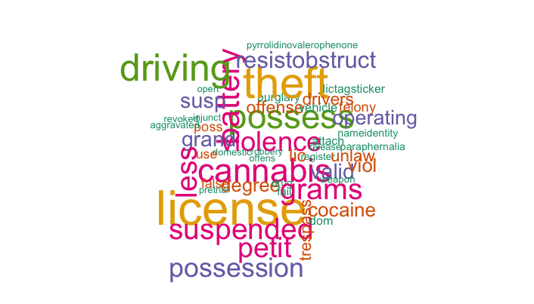

**Distribution of Decile Scores, by Race**

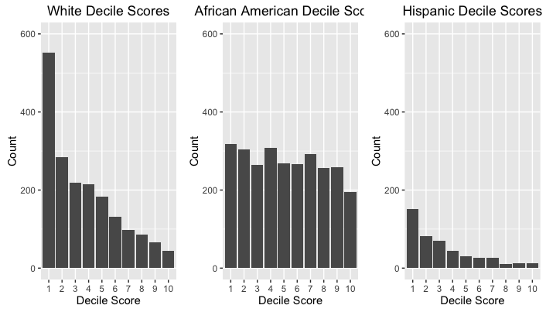

**Regression Output for Risk Score And Recidivsm**

Descriptive Statistics

================================================================================

Dependent variable:

----------------------------------------------------

decile_score recid

(1) (2)

--------------------------------------------------------------------------------

gender_factorFemale 0.139* -0.092***

(0.072) (0.016)

age_factor26-30 -1.284*** -0.079***

(0.088) (0.020)

age_factor30-40 -1.933*** -0.164***

(0.079) (0.018)

age_factor40-50 -2.809*** -0.239***

(0.095) (0.021)

age_factor50+ -3.454*** -0.285***

(0.097) (0.022)

race_factorAfrican-American 0.882*** 0.102***

(0.105) (0.024)

race_factorCaucasian 0.419*** 0.057**

(0.107) (0.024)

race_factorOther -0.283* 0.025

(0.146) (0.033)

priors_count 0.268*** 0.031***

(0.007) (0.001)

recid1 0.743***

(0.061)

crime_factorM -0.501*** -0.033**

(0.059) (0.013)

Constant 4.420*** 1.464***

(0.114) (0.025)

--------------------------------------------------------------------------------

Observations 5,425 5,425

R2 0.468 0.141

Adjusted R2 0.467 0.140

Residual Std. Error 2.061 (df = 5413) 0.463 (df = 5414)

F Statistic 433.577*** (df = 11; 5413) 89.100*** (df = 10; 5414)

================================================================================

Note: *p<0.1; **p<0.05; ***p<0.01